THE ENGLISH LANGUAGE UNIT YANBU UNIVERSITY COLLEGE YANBU INDUSTRIAL CITY SAUDI ARABIA | 
Final Project
Academic Year 2019 – 20G (1440 – 41 H) Fall Semester 191

ENGL 211- Business Report Writing

Submission: December 8, 2019

Student's Name: Murtaja Mohammed Al-rajab

Student’s ID:

3 | 7 | 2 | 0 | 2 | 3 | 9

FOR INSTRUCTOR'S USE ONLY
Section: 2
_
General Instructions:
Follow the Instruction Given in Each Section of this Project + Class Instructions

SIGNATURE:
MARKED BY:
MARK AWARDED:
TOTAL MARK: 40

Some Parameters about Producing Pulp/Paper in the Green Valley City

Name: ID:
Department: Specialty: College: Date:

Font: Times New Roman Size: 12
Space between lines: 1

Introduction

- The aim of the report
(2 points)

- Very short paragraph to show the goal of this short report (what elements and components you need to analyze)

- Types of data in the report

Method

(5 points)

- Types of diagrams/graphs you will analyze

Results and Discussion

Basic Process Diagram (12 Points)

Instructions:

    - Write extended paragraph around (300) words
    - Include definition of terms
    - Use the websites below or any references

https://www.testbig.com/ielts-writing-task-i-ielts-academic-essays/diagram-gives- information-about-process-making-pulp-and
https://www.pulpandpaper-technology.com/articles/pulp-and-paper-manufacturing- process-in-the-paper-industry
Avoid Copy/Paste

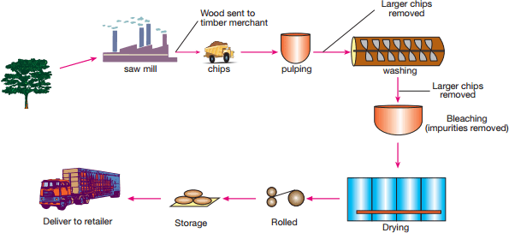

  - Basic Parameters about Paper Pulp Production (15 points)

Instructions:

    - Fill in the missing columns in the table (in orange)
    - Convert the table into three suitable graphs
    - Write extended paragraph around (240) words to describe the table and graphs Previous and Projected Parameters of Pulp Production (2000 to 2035)
Year | Production in  Tons (in million) | Exports in  Tons (in million) | Local Sales in  Tons (in million) | Storage (in million) | Percentages (of exports) | Percentages  (of local sales)
2000 | 80 | 2 | 65 | 13 | 2.5% | 81.25%
2005 | 86 | 2 | 44 | 40 | 2.33% | 51.16%
2010 | 89 | 8 | 8 | 73 | 9% | 9%
2015 | 120 | 8 | 102 | 10 | 6.66% | 85%
2020 | 240 | 12 | 230 | 0 | 5% | 95%

2025 | 280 | 20 | 282 | 0 | 7.14% | 93.57%
2030 | 340 | 20 | 320 | 0 | 5.88% | 94.12%
2035 | 550 | 50 | 500 | 0 | 9.1% | 90.9%

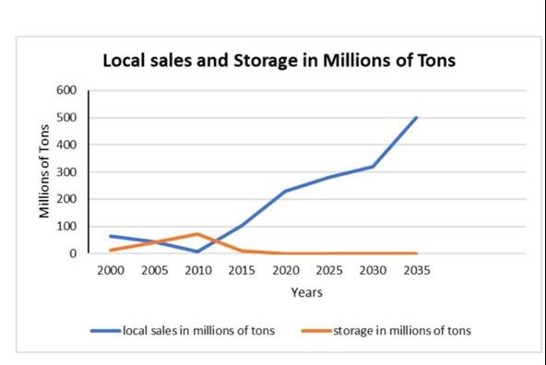

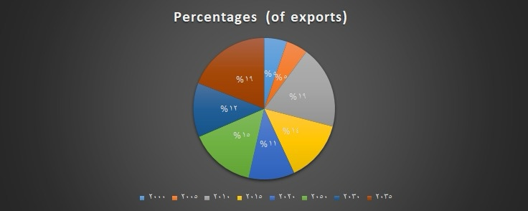

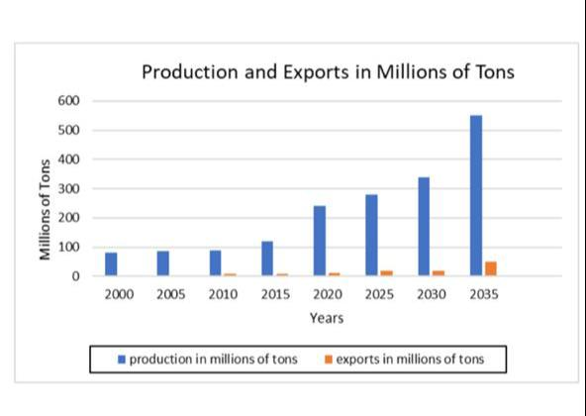

Conclusion

(3 points)

Work Cited (3 points)

Use APA Citation Generator
http://www.citationmachine.net/apa/cite-a-website

